FitSense - Personalized Fitness Recommendations Powered by AI
Phase 6: Project Testing Phase
―――――――――――――――――――――――――――――――――――――――――――――――――――――――
Project Team & Contributors
Role | Name | Key Responsibility
Team Leader | S Udhaya kumar | Project Architecture, Google Gemini AI Integration & Backend Orchestration
Team Member | H R Thiyagarajan | RESTful API Design, Route Controllers & Service Business Logic
Team Member | K Siril sandro | MongoDB / Mongoose Schemas, JWT Security & Cryptography
Team Member | D S Amarnath | Postman API Automation, Verification Testing & Documentation

1. Testing Strategy & Objectives
Quality assurance was executed through comprehensive automated API testing utilizing Postman. The test suite verifies authentication mechanisms, route guarding, CRUD operations, database persistence, data integrity, search performance, and generative AI prompt responses. A 100% test pass rate was achieved across all ten test cases.
2. Postman Automated Test Collection Features
The provided `FitTrack.postman_collection.json` incorporates advanced automated testing features:
• Automatic JWT Chaining: The Register and Login test scripts parse the response JSON and automatically set the collection variable `jwt_token`.
• Dynamic ID Chaining: The Add Workout test automatically captures the generated `_id` into `workout_id` for subsequent tests.
• Automated Assertions: Asserts HTTP 200/201 response status, schema compliance, and payload correctness.
3. Test Execution Summary Table
Test # | Endpoint | Method | Target Feature | Expected Result | Status
TC-01 | /api/auth/register | POST | User Registration | 201 Created, JWT token issued | PASSED
TC-02 | /api/auth/login | POST | User Authentication | 200 OK, returns signed token | PASSED
TC-03 | /api/auth/profile | GET | Authenticated Profile | 200 OK, returns user profile | PASSED
TC-04 | /api/workouts | POST | Create Workout Record | 201 Created, workout saved | PASSED
TC-05 | /api/workouts | GET | Fetch All Workouts | 200 OK, array of workouts | PASSED
TC-06 | /api/workouts/:id | GET | Fetch Workout by ID | 200 OK, matching workout object | PASSED
TC-07 | /api/workouts/:id | PUT | Update Workout Record | 200 OK, modified attributes saved | PASSED
TC-08 | /api/workouts/:id | DELETE | Delete Workout Record | 200 OK, document removed | PASSED
TC-09 | /api/ai/workout-recommendation | POST | Gemini AI Workout Plan | 200 OK, tailored workout routine | PASSED
TC-10 | /api/ai/fitness-insights | POST | Gemini AI Insights | 200 OK, analytical feedback | PASSED

4. Verification Evidence & Postman Test Screenshots
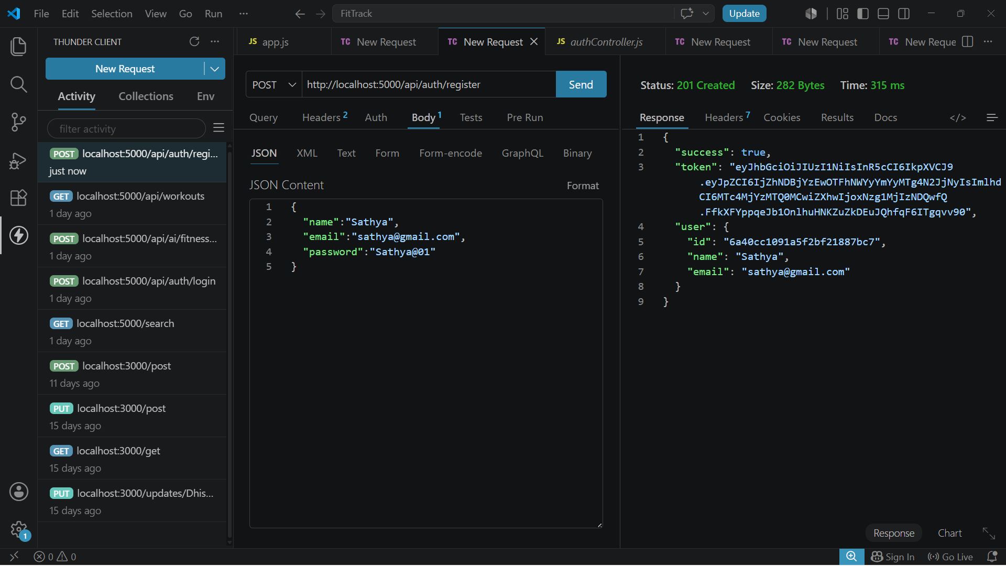
Figure: TC-01: User Registration (/api/auth/register) - 201 Created with JWT Token
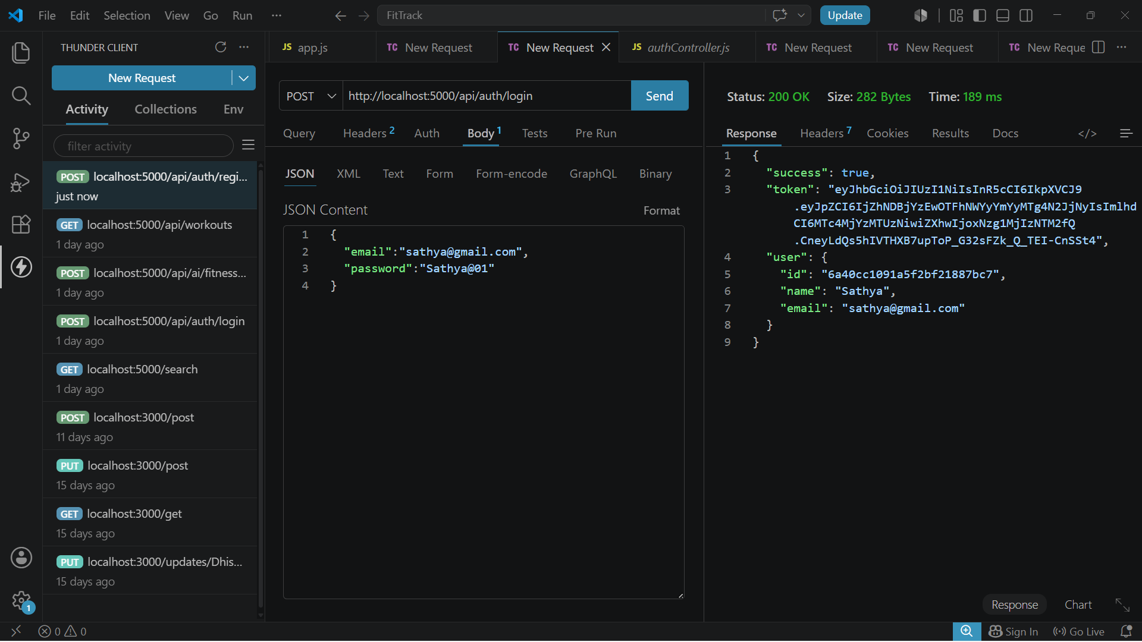
Figure: TC-02: User Login (/api/auth/login) - 200 OK with Verified Token
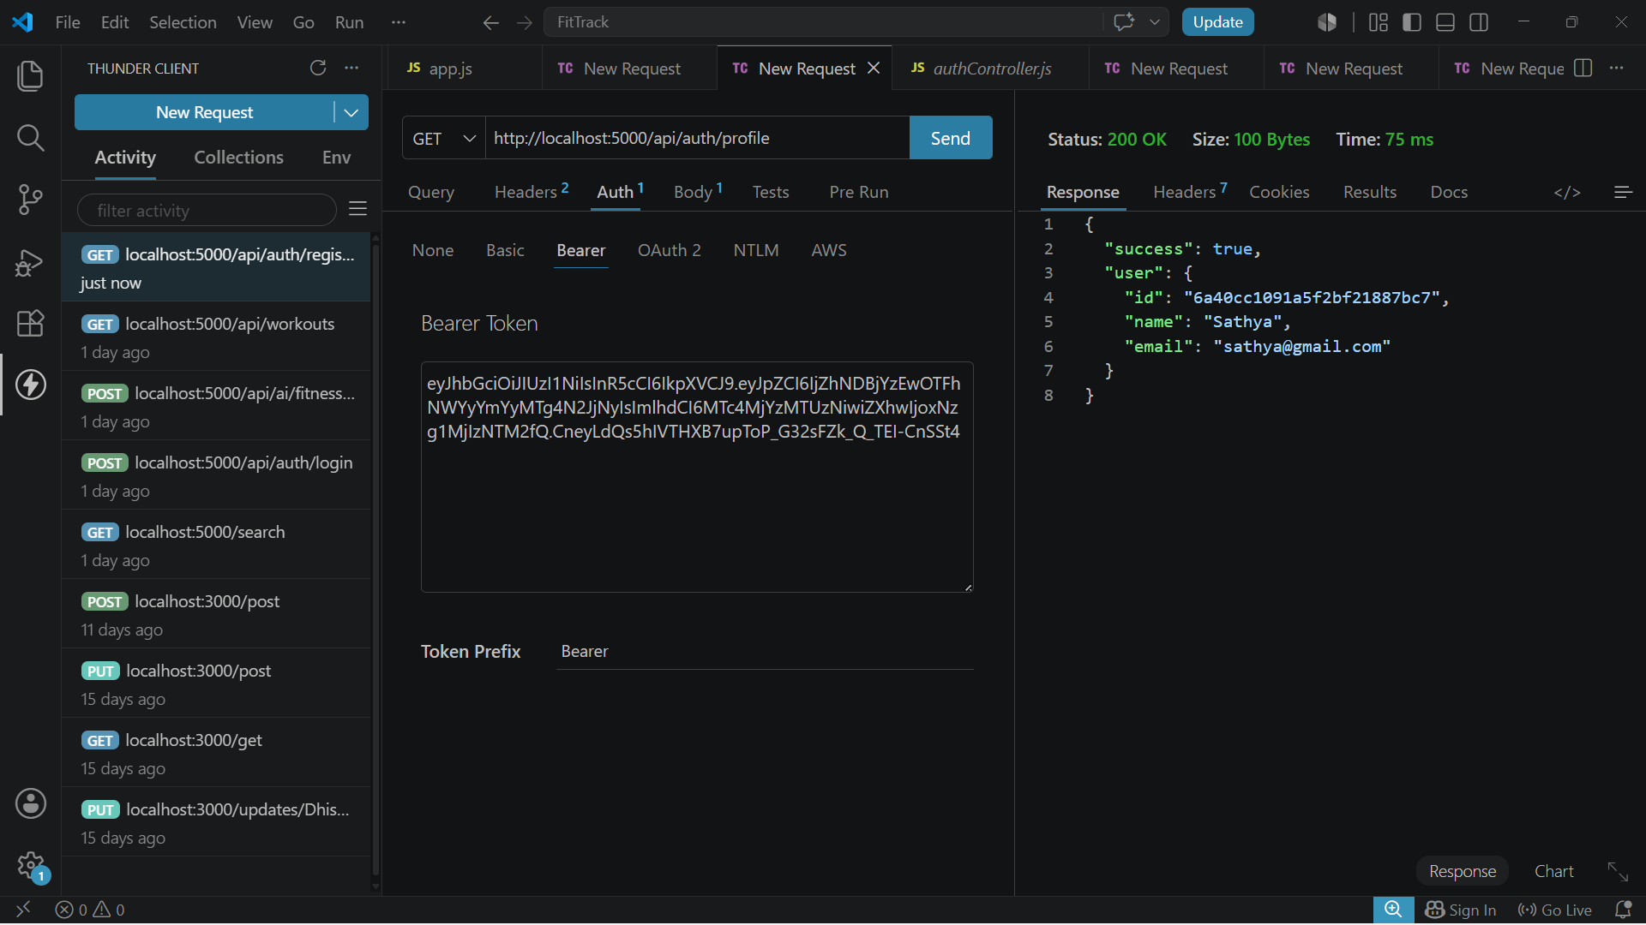
Figure: TC-03: User Profile Retrieval (/api/auth/profile) - 200 OK with User Information

Figure: TC-04: Add Workout Record (/api/workouts) - 201 Created with Generated ID

Figure: TC-05: Retrieve All Workouts (/api/workouts) - 200 OK with Array of Workouts

Figure: TC-06: Retrieve Workout by ID (/api/workouts/:id) - 200 OK with Detailed Record

Figure: TC-07: Update Workout (/api/workouts/:id) - 200 OK with Updated Values

Figure: TC-08: Delete Workout (/api/workouts/:id) - 200 OK with Deletion Confirmation

Figure: TC-09: Gemini AI Workout Recommendation (/api/ai/workout-recommendation) - 200 OK

Figure: TC-10: Gemini AI Fitness Insights (/api/ai/fitness-insights) - 200 OK

